**Jorge Esteban Artalejo Rivas Personal Bio**

My name is Jorge Esteban, Student number s3874914 I'm 35 years old and a member of the “*Fighting Mongooses” I* was born in the city of Tijuana Mexico. I'm not very sure about my heritage, but all my family has been born in Mexico. most people in Mexico are “mestizos” which means we are a mix of indigenous and European decent, mostly Spanish, I speak Spanish as my mother tongue and English as my second language. one very interesting fact about me is that I don’t like spicy food, something very rare is you’re are from Mexico. as for a hobby I love to play football (soccer), I play at least once a week and it also helps me to keep in shape. I play midfield or left wing. Another aspect about me is that I'm married, and I have a 2-year-old daughter. I moved to Australia back in 2012. Since then I have had many jobs. I tried to continue my career in Australia as an environmental technician. but I realize that I was not enjoying that career anymore. since 2014 I started to work in supermarkets and liquor stores, which I found very fun to work in. Since then I moved up getting more responsibilities until I was offered a job in Hamilton island as a liquor store manager back in 2016 and since then I've been living in Tropical Hamilton island.

About my interest in IT, I’ve always been very interested in this field. Always curious about the technology it uses and how it works. I came to realize during this pandemic how important is to be communicated and the importance of IT in the business sector. Thanks to IT a lot of business were able to keep working otherwise they would have gone bankrupt. this really got my interest in wanting to know more about IT and the services it provides.

**Personal Profile**

The result of the Mayers-Brigss result: Campaigner

I found this result very accurate. I'm the type of person that can be introverted and extroverted at the same level. I'm the kind of person that likes to meet new people and make friends. Also, I like to maintain those bonds with the other person. at work I'm always looking after other people and looking to after them before me. when I'm working with other people, I'm always traying got create a good working environment with my coworkers. So, everybody can work at their best. that’s not always the case as we all know things in real life can be a lot more complicated.

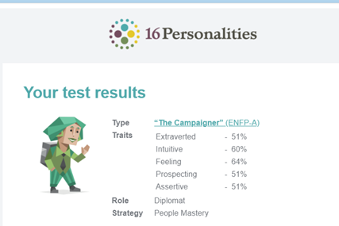

**Big five test personality Test result**

This Big Five assessment measures your scores on five major dimensions of personality: Openness, Conscientiousness, Extraversion, Agreeableness, and Neuroticism (sometimes abbreviated OCEAN). Check out your scores on each of the five dimensions in the graph below, then read on to discover what each score means.

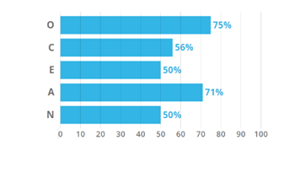

**Ideal Job IT support specialist**

My ideal job would be to become an IT support specialist. I choose this job because I think this is a great job for someone with my skills. I think this is a great job to start a career in the IT industry. I have a lot of experience talking to customer and answering to their queries.

IT experience for IT support specialist is between 3-5 years

For job vacancies as for 2020 there is 9748 positions available according to Seek

This are the Duties & skills required to work in this field